Annual Report of Education Project of Dhas Gramin Vikas Kendra 2014-2015
The work of the Dhas Gramin Vikas Kendra (DGVK) on the education front has gone from strength to strength with many new achievements this year. The education project now encompasses the residential Rani Kajal Jeevan Shala in Kakrana in addition to the three single teacher schools in Khatamri, Chilakda and Bada Amba. Even though the Rani Kajal Jeevan Shala is managed by the Kalpantar Shikshan Society set up separately to administer the school, an important new development that will be described by and by has led to the involvement of the Dhas Gramin Vikas Kendra (DGVK) also in supporting the initiatives there.
This year too trainings were organised for the teachers in the three schools and these trainings were held in Vakner village so as to keep the content localised. The three single teacher schools have improved their performance over the past year and the details are given below.
I. BADA AMBA
There are now 70 students in the school in Bada Amba as opposed to 62 last year. The details of the total enrolment age and gender wise is given in Table 1.
Table 1: Total Enrolment in School in Bada Amba
Age in Years | 6 | 7 | 8 | 9 | 10 | 11 | 12 | 13 | Total
Boys | 7 | 6 | 6 | 2 | 3 | 4 | 5 | 3 | 36
Girls | 6 | 6 | 6 | 2 | 3 | 4 | 5 | 2 | 34
Total | 13 | 12 | 12 | 4 | 6 | 8 | 10 | 5 | 70

The teacher supported by the DGVK, Mavsingh Vaskel, has also got an appointment as a guest teacher with the Madhya Pradesh Government Education Department and the school has been registered as a primary school under the provisions of the Right to Education Act due to the efforts of the DGVK. In fact the vigorous campaign carried out by the DGVK has resulted in as many as 30 new schools being sanctioned by the Government in Alirajpur district. As a result examinations are conducted in accordance with the directives of the Education Department and the students are graded on their performance. All the students have passed their examinations and currently there are 14 boys and 9 girls in Class One, 6 boys and 6 girls in Class Two, 7 boys and 5 girls in Class Three, 5 boys and 5 girls in Class Four and 4 boys and 9 girls in Class Five. The registration of the school with the Education Department has also resulted in mid-day meals being provided to the students by the Government. The villagers have got together and constructed a separate wooden school building. The adult members of the Khedut Mazdoor Chetna Sangath sit in the school in the evenings for adult education classes from the teacher Mavsingh.
II. CHILAKDA
There are now 65 students in the school which is seven more than last year. The details of the total enrolment age and gender wise is given in Table 1.
Table 2: Total Enrolment in School in Chilakda
Age in Years | 6 | 7 | 8 | 9 | 10 | 11 | 12 | 13 | Total
Boys | 3 | 6 | 14 | 4 | 2 | 1 | 1 | 4 | 35
Girls | 4 | 5 | 9 | 3 | 2 | 4 | 1 | 2 | 30
Total | 7 | 11 | 23 | 7 | 4 | 5 | 2 | 6 | 65
The teacher in Chilakda, Naharsingh, too has been appointed as a guest teacher by the Madhya Pradesh Government Education Department and the school has been subsumed under the Primary School being run in the nearby Nal Amba hamlet. Consequently the children here are getting their mid day meal from the Government. They have performed well in their examinations and all have passed. The current classwise student strength is as follows. There are 7 boys and 6 girls in Class One, 8 boys and 5 girls in ClassTwo, 7 boys and 5 girls in Class Three, 8 boys and 6 girls in Class Four and 7 boys and 6 girls in Class Five.
III. KHATAMRI
There are currently 32 students in the school up from 22 last year. This school too has been registered by the Government of Madhya Pradesh Education Department and a separate teacher has been appointed. Consequently the teacher appointed by the DGVK, Sena Bai, provided extra tuition classes in the morning before the start of the school at 11 am. The details of the total enrolment age and gender wise is given in Table 3 below.
Table 3: Children Regularly Attending School in Khatamri
Age in Years | 4 | 5 | 6 | 7 | 8 | 9 | 10 | Total
Boys | 2 | 3 | 1 | 1 | 5 | 2 | 1 | 15
Girls | 2 | 3 | 3 | 1 | 4 | 2 | 2 | 17
Total | 4 | 6 | 4 | 2 | 9 | 4 | 3 | 32

All the students have passed their examinations and the classwise strength is as follows. There are 5 boys and 5 girls in Kindergarten, 2 boys and 4 girls in Class One, 6 boys and 5 girls in Class Two and 2 boys and 3 girls in Class Three. Since a government teacher has been appointed separately for this school and Sena bai has expressed the desire to work in community mobilisation and not as a teacher, the tuition school will be closed and instead from the next session a new school will be started in the village of Khundi which does not have any school.
IV. RANI KAJAL JEEVANSHALA
Multigrade teaching in single teacher schools by inadequately qualified and trained teachers results in poor pedagogy and learning outcomes. That is why the DGVK established a residential school with many teachers in Kakrana village on the banks of the Narmada River in 2001. A separate organisation was set up for this so as to keep the school independent of the DGVK and its other developmental activities. However, last year Professor Swapan Bhattacharya, a retired, internationally renowned micro-biologist who had worked and taught in the Bhabha Atomic Research Centre, Tata Institute of Fundamental Research and the Devi Ahilya University in Indore, came to know about the work of the DGVK from the internet where he had searched for a good organisation working among the Bhil Adivasis with which he could associate. He visited the Rani Kajal School in Kakrana and liked the place immensely and expressed a desire to stay in the school and give his inputs. He said that after retirement he had spent five years searching for a good institution to work in with children and he had finally found one. The only problem was that the spartan living arrangements in Kakrana where there were only a few toilets for the girl students and the guest house did not have proper electricity were too daunting for the seventy year old professor who is both an asthma and a heart patient. The Kalpantar Shikshan Trust which runs the school on a shoestring budget with some help from outside and some fees from the students had no funds to spruce up the guest house with proper toilet, electricity and water facilities. So, since the DGVK education project had a surplus due to the munificient donations received last year which were Rs 10,000 in excess of the target of Rs 2 Lakhs, funds amounting to Rs 80,000 were transferred from this to the Rani Kajal Jeevan Shala for the guest house renovation and remodelling project.
Professor Bhattacharya is now in residence in Kakrana since January 2015 and has established a laboratory, library, a garden and an insect park in the school. He conducts classes for the teachers and the children and also has taken on the task of documenting the bio-diversity in the dense forest protected by the villagers through community cooperation. A new dynamism has been added to the Rani Kajal School. The following is a brief description of the plans that he has drawn up for further developing the school.
- Achievements of the Rani Kajal School so far:
The number of students have increased over the years. The number increased from 40 in 2001 to 211 studying upto Class Eight currently. Of late the school has to refuse a number of applicants because of shortage of rooms. Most students have pursued higher level of studies at least upto 12th Class (Higher Secondary). A few have made it to college level also and are continuing their studies. Some motivated students of the past have remained in the village and are trying their level best to keep the school running. Present students have intense interest in learning. But teaching method needs changes to go beyond rote learning.
- The weakness of current practices and ways to eliminate them
- The most important weakness is open defecation by the boys who do not have toilet facilities. There are only 3 latrines for girls and staff members. Not at all adequate for the number of girls and staff who use them. Even the bathing rooms, only 3, are without any water taps and without doors. This is in spite of the fact that there is enough subsoil water available, being close to the Narmada and electricity is available almost 24 hrs. The cumulative effect of open defecation is an enormous health hazard. Therefore, many more toilets have to be built.
- Use of firewood from jungle on the banks of Narmada is another criminal practice that must be eliminated. They collect dry wood from the banks every 7-10 days cruising along the river to distances upto 20-40 Km. At times, not infrequently, they ask the students, juvenileand grownups, boys and girls alike in the manner of military drills to carry dry wood from nearby and distant vendors who find it an easy business at the cost of damage to the environment. The sight of kids carrying fire woods may appear amusing, but is equally dehumanising. The time wasted on such fuel collection is an enormous loss to the teaching schedules and learning time of the students. Also the effect on the health of the cooks who spend hours in the fireplace is hazardous, breathing smoke nearly the whole day. They are likely to develop serious illness in near future if this practice is not discontinued immediately. Therefore, efficient wood stoves or solar parabolic stoves have to be installed.
- An extremely hazardous practice is the sweeping of the ground with broom sticks. It raises dust clouds right at the doors of their hostel-cum-class rooms to send back the dust where they spend most of the time, day and night. They fall sick very frequently and tend to play out in the open dusty fields or on denuded hillocks. This is because they don’t have any good reading rooms or play grounds to attract them. We need to solve these problems in an integrated manner by firstly planting lawns all around and building a fence to protect them from grazing cattle, making dscent pavements for movement in the campus complex and secondly by building large reading rooms with modern facilities enjoyed by urban counterparts, at least two, to attract the students to use them. One for KG to class 3 and the other for students of Class 4 to 8. The rooms have to be airy, lighted and well furnished. The students should, even without explicit persuasion, prefer to study there whenever they wish instead of following the old practice. Later laboratories also have to be built. There is also a need for a dining room as at present the students eat in their rooms or on an open platform as shown below.
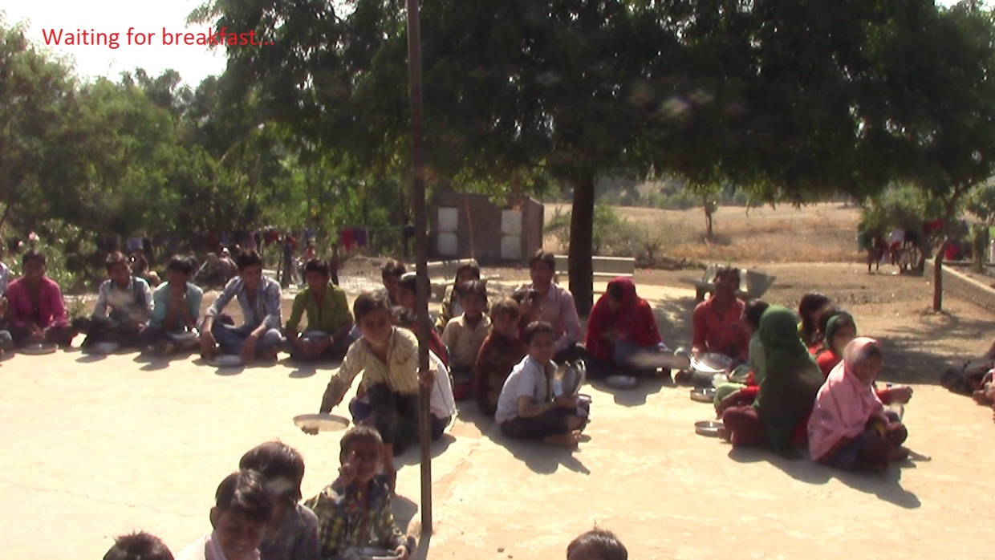
Fig. 1: Children awaiting Breakfast on an Open Platform
A small experiment was done recently in last three months asking the students to grow ornamental flower plants and seasonal vegetables from seeds in a small garden plot developed with soil brought from Narmada bank. Their enthusiasm was boundless. They dug-up the plot, readied itfor sowing plants. They were shown and asked to use coco-pits in seeding trays to develop plantlets from seeds and transfer these to marked tiny zones each for one student, in the garden. This was a hugely successful activity and needs to be expanded for the whole school. Four of the students even took their plants in pots home on this vacation to show their parents and other villagers.
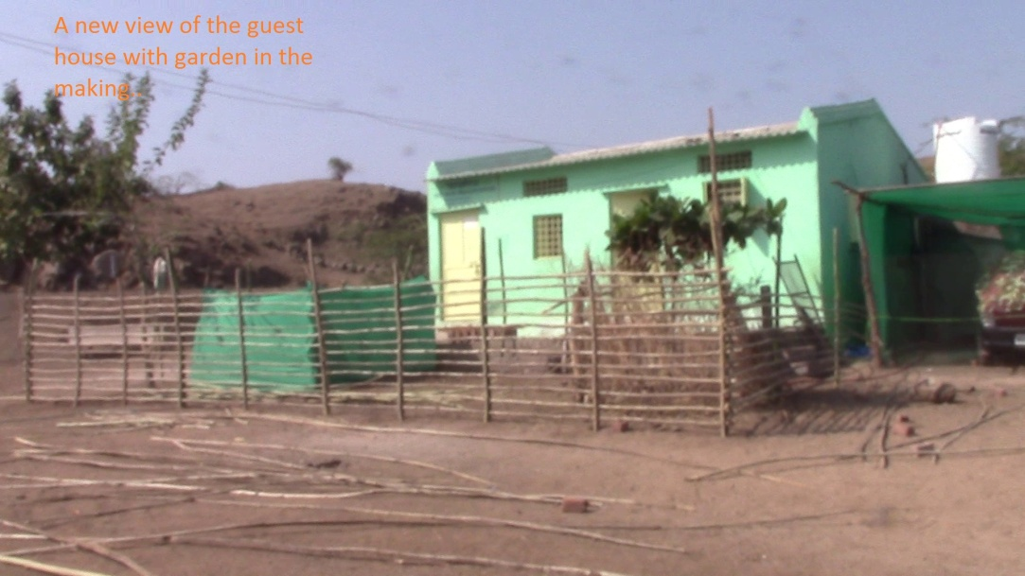
Fig. 2: The Renovated Guesthouse cum Laboratory and Garden
The children also participated in culturing butterflies, learning as these metamorphosed from eggs through their multiple instars to give birth to beautiful butterflies. We have a tiny butterfly park made within the experimental garden to exhibit these cultured butterflies.
The point is these are extremely useful science experiments right in nature. These exercises will pace up their rate of learning and with pleasure. Both the students and teachers are equally enthusiastic. Learning will be that much less of a burden from rote learnings which is the current mode of teaching in this school. So the school needs to develop larger number of plots (3m x 3m size each) to be allotted to groups of 3-4 students each for a year. They will only have to be taught some horticulture and gardening practices because most being farmers children, know rudiments of these. They can be made more technically aware of the needs of the environment conservation through these exercises. A special course can be designed for these gardening activities without employing any fresh teacher specifically for gardening.
- One factor that will certainly attract better qualified teachers from towns and cities to join the school is descent accommodation. The current staff is a motivated lot. Moved by ideology they work all the time to solve the problems of the institute while staying in dingy houses. Most of them have turned jacks of all trades for services and maintenance to run the school. They should be given better accommodation to begin with. The fresh teachers will look upon the job professionally. Being unlikely to be driven by ideological zeal, they will have to be provided with facilities comparable to those available in good urban schools. Some quarters ready to accommodate willing fresh teachers must be constructed.
- Lack of stable electric supply hampers all activities routinely. That includes study, water supply and whatever few essential appliances are deployed to run the kitchen. Though the availability is for 24 hours in principle officially, in practice the vagaries of the connections and variable load beyond control of the school, effectively reduces the available power to nearly half the time at best and timings are unpredictable. The Civic Administration have said that the school being private has to spend on a transformer and cable laying to officially ask for power free of these problems.
- There is no network for use of mobiles within the premise of the school building or staff quarters. One has to go to a few specific points or go to the top of hillocks to get reasonable signals for mobile but near zero for internet. The school has to be given an internet provision urgently. This will increase the pedagogic level. The quality of both the students and teachers will be instantly enhanced beyond their expectation and encourage them to use it as teaching aid. It cannot be denied that internet is a must for education at all levels today.
There is an effort going on to get an internet hub to the school using a new technology for large areas with radio access network from service provider at Alirajpur.The distance is about 70 Km. A relay point has to be established on top of a hillock which comes on the way. This will need funding for a tower.
V. FINANCES
Clearly, considerable funds are required over a period of time to remove these weaknesses and transform the Rani Kajal School into a better one and the Kalpantar Shikshan Kendra is trying to raise them through its sources. However, the DGVK also has to contribute and so this year the target will have to be more than the Rupees Two Lakhs that was set and easily achieved last year. Instead of putting a target it would be better to keep the fund raising process ongoing and open ended so that as and when funds become available the targeted development works enumerated above can be undertaken for the improvement of the Rani Kajal School.
Rupees Fifty Thousand was carried forward from last year and Rupees Two Lakh and Ten Thousand were collected from donors this year for a total available funding of Rupees Two Lakh Sixty Thousand. Rupees One Lakh Fifty Three Thousand were spent on salaries of the teachers of the three schools and their training. Rupees Eighty Thousand were spent on the renovation and refitting of the guest house in the Rani Kajal School in Kakrana. Thus, a sum of Rupees Twentyseven Thousand has been carried forward to the 2015-16 session.
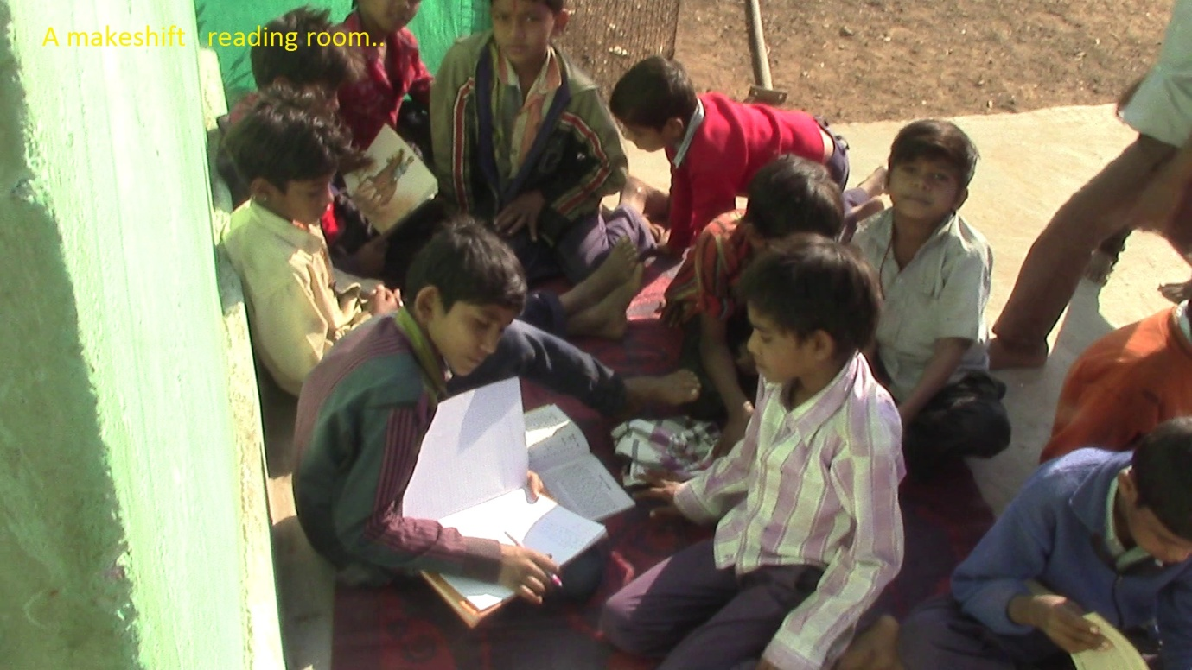
Fig. 3: Children Studying on the Platform in Front of the Guesthouse in the absence of a Reading and Room and Library.

